**Diary Writing**

**Meet Sheladiya – 19BIT076**

**Assignment – 2**

**Relational Model**

Well, the concept of this assignment i.e., to make a relational model of our data set was new to us so we were quite excited to perform this with the participation of whole group. Again, as a team we divided our work and started working on it. We were asked to give 4*N tables therefore every member came up with 4 entities and their attributes, before finalising we had a group discussion on the entities provided by all the members to make the model unique and efficient. I worked upon **Payment method, card details, confirmation and audience temperature.** I made the tables with these entities and attributes and highlighted the respective Primary Key. We had a final discussion and the compilation was done along with the discussion and we also had a discussion over Foreign Key to relate the tables with each other. Finally, our Assignment 2 was completed and it was as it was supposed to be.

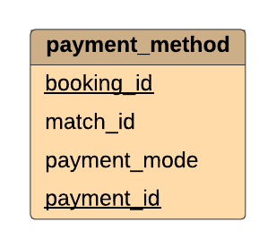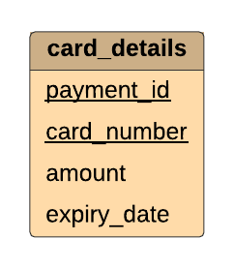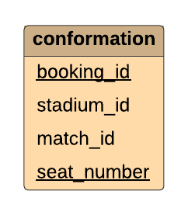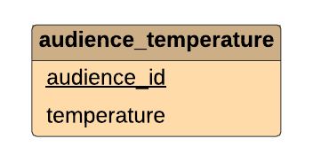

**Assignment – 3**

**ER Model**

This assignment was related to the previous one it was a complete team work as we were supposed to make the relations between the tables, like in my case the card details table was related to payment method and it was further related to confirmation after successful payment. The audience temperature was not related to above three therefore we made the relations of all the leftover tables through group discussion with all the members. And then a complete E-R model was made with the help of an online software – [Lucid chart](https://lucid.app/lucidchart/21c4d692-d021-4418-a7e8-7b0c9c5d97c6/edit?page=0_0)

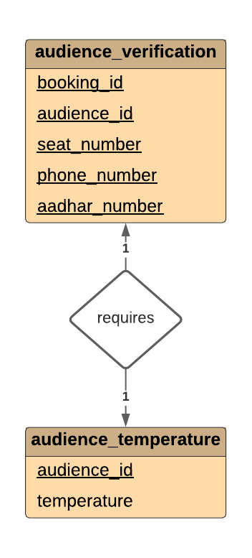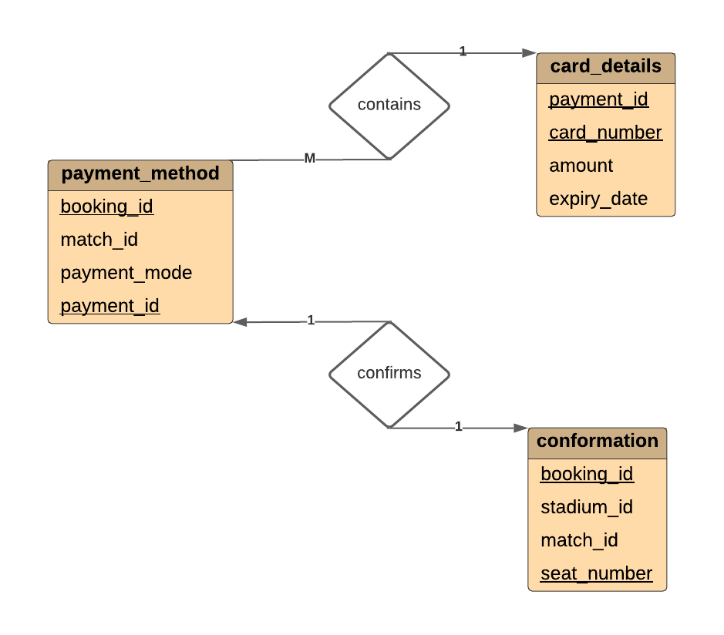

**Renish Jagani – 19BIT108**

**Assignment -2**

**Relational Model**

After our first assignment we got the second one and this time it was something which we never heard of before and everyone was little confused regarding the assignment 2, So we decided to have a discussion and then we discussed a lot amongst ourselves after taking the idea from our study material, Google and watched some YouTube Videos. After few discussions we got clarity of this particular Project, the task was to make a relational model of the data base system and there needs to be 4*N tables so the distribution work took place and everyone got their fields.

I made the table’s fixtures**, venue, home_ team, away team.** Th**e** task was to make the table using these entities and attributes and underlined the Primary key of each table. The last task was to decide the foreign key to relate all the tables to each other. At the end after so much of discussion and hard work our second assignment was ready to upload.

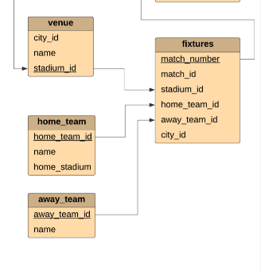

**Assignment – 3**

**ER Model**

After the second assignment the third one was co related to the second one, the task was to make out the relations between all the tables. Two out of four entities that I had were related the other two were not related so we had an online meet to relate the tables with the tables of other group members. We did a lot of discussions and worked out the things for a perfect model. We had a lot of contradictions but then after working out on them finally, the relations were made for all the tables and the task was done in an online platform.

Every group member played their role of completing the task on time, everyone helped each other in their doubts and confusions and this eventually increased our understanding and team spirit.

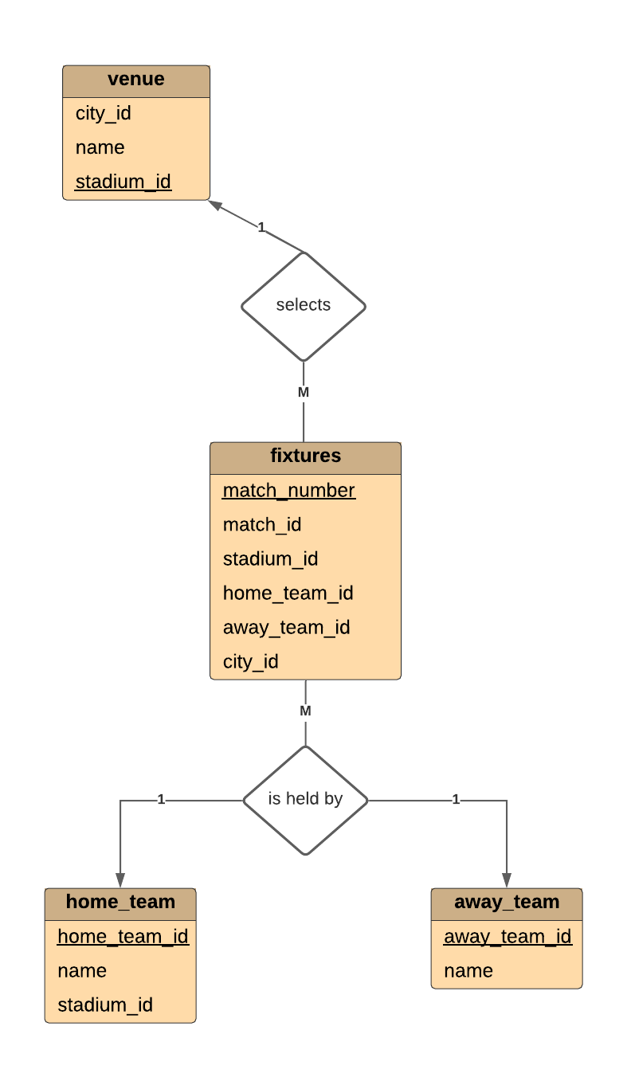

**Rishit Samariya – 19BIT109**

**Assignment-2**

**Relational Model**

This assignment was also a group assignment in which we have also develop group spirit and bonding. In this assignment every student have given idea of entity and there attribute we have called meeting in which every student have given 4 entity and there attribute to. If by chance it lead that there is common entity then we have solved that problem in group and it help us to figure it out. I am given the area to find entity and its attribute related food and beverage and jersey of team. So I have made the 4 table with their entity and attribute in which Primary key was underline.

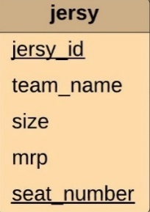 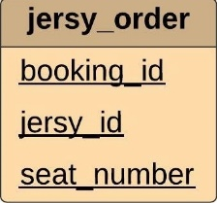 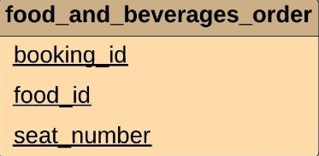 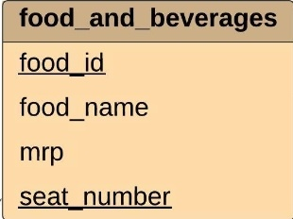

Then by gathering all detail by group member we have made the Relational model in group by giving the idea of foreign key To relate the table with each other. And we have finalise the Relatinal model in online platform.

**Assignment-3**

**E-R model**

This Assignment was based on assignment 2 which was Relational model after making of Relational model I have make relation between the tables which I have made to other. Between the jersey and jersey order there will be relation of order which will be denoted by diamond and entity will be denoted by rectangle. Same in Food and beverages and Food and its Food and Beverages order there will be same relation of order. And also given the relation between Seat Details Entity with Food and Beverages entity and Jersey entity the relation I have given was of view. Then we have given idea in Group and then we have made the diagram through online platform ([https://lucid.app/lucidchart/21c4d692-d021-4418-a7e8-7b0c9c5d97c6/edit?page=0_0#).](https://lucid.app/lucidchart/21c4d692-d021-4418-a7e8-7b0c9c5d97c6/edit?page=0_0%23).%20) Then I have also given 1 feature of Stadium which is listed in the PPT that we have made. This all work has been finalised in the PPT.

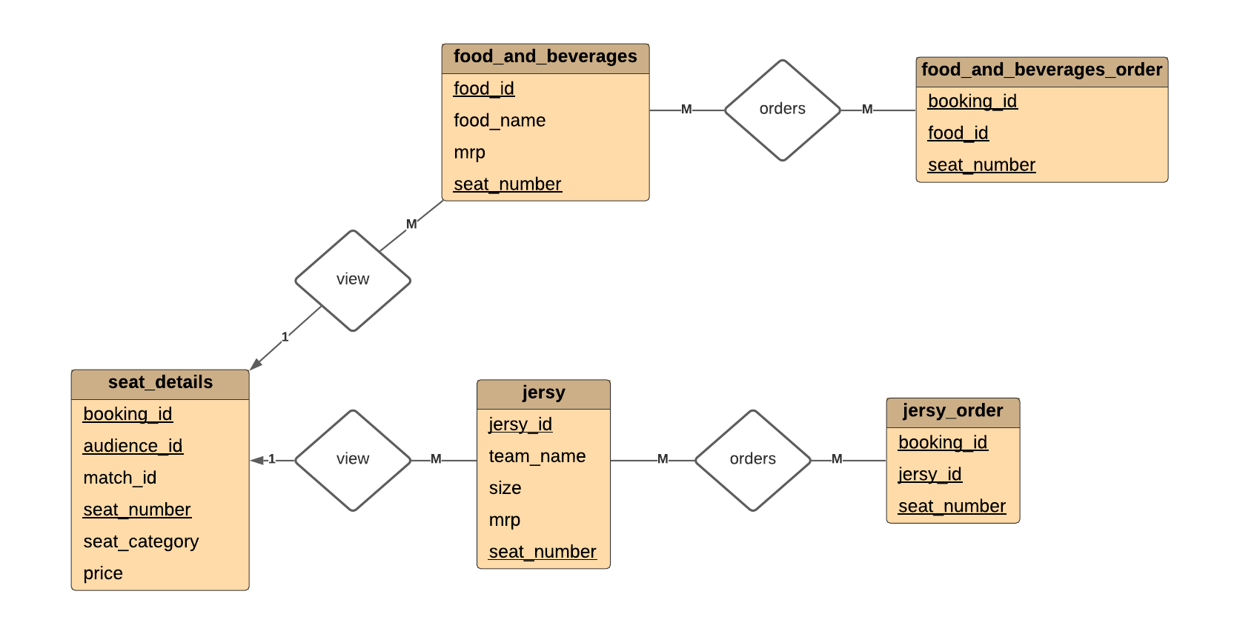

**Rishabh Patel - 19BIT141**

**Assignment – 2**

**Relational Model**

In the assignment – 2 we work on relational model where first I create my 4 input tables that are login table, seat booking table, seat location table, seat detail table and then we started making diagram in lucid chart where we first made rectangle tables for attributes and then we find super keys, primary key and foreign key. I underlined the attributes for primary key. Then I find relations between each of the four tables. By calling a meeting we solved the problems which occurs between each other input tables and came up with more relevant solution. Finally we evaluate each other work and merge the final work done by all team members.

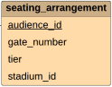 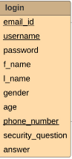 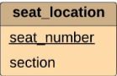 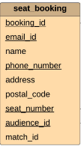 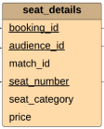

**Assignment – 3**

**ER Model**

The Assignment – 3 is Entity Relational modeI and because Relational model is simpler model of ER model and so it is very convenient of us. I made the relation sets between the assigned input tables and created the entity sets for the attributes and shown the symbols used in ER model and represents the aggregation through schema. For Instance login and seat booking has relation set of user registration shown that one user can book many seats for each match. Similarly for seat booking and seat detail there one-to-one relation because for each seat there can only be single data in seat detail. We initially created ER model in Visual paradigm but then we moved to lucid chart because it provides more feature and it is more user interactive. Then we finally evaluate our work and merge final output of all team members.

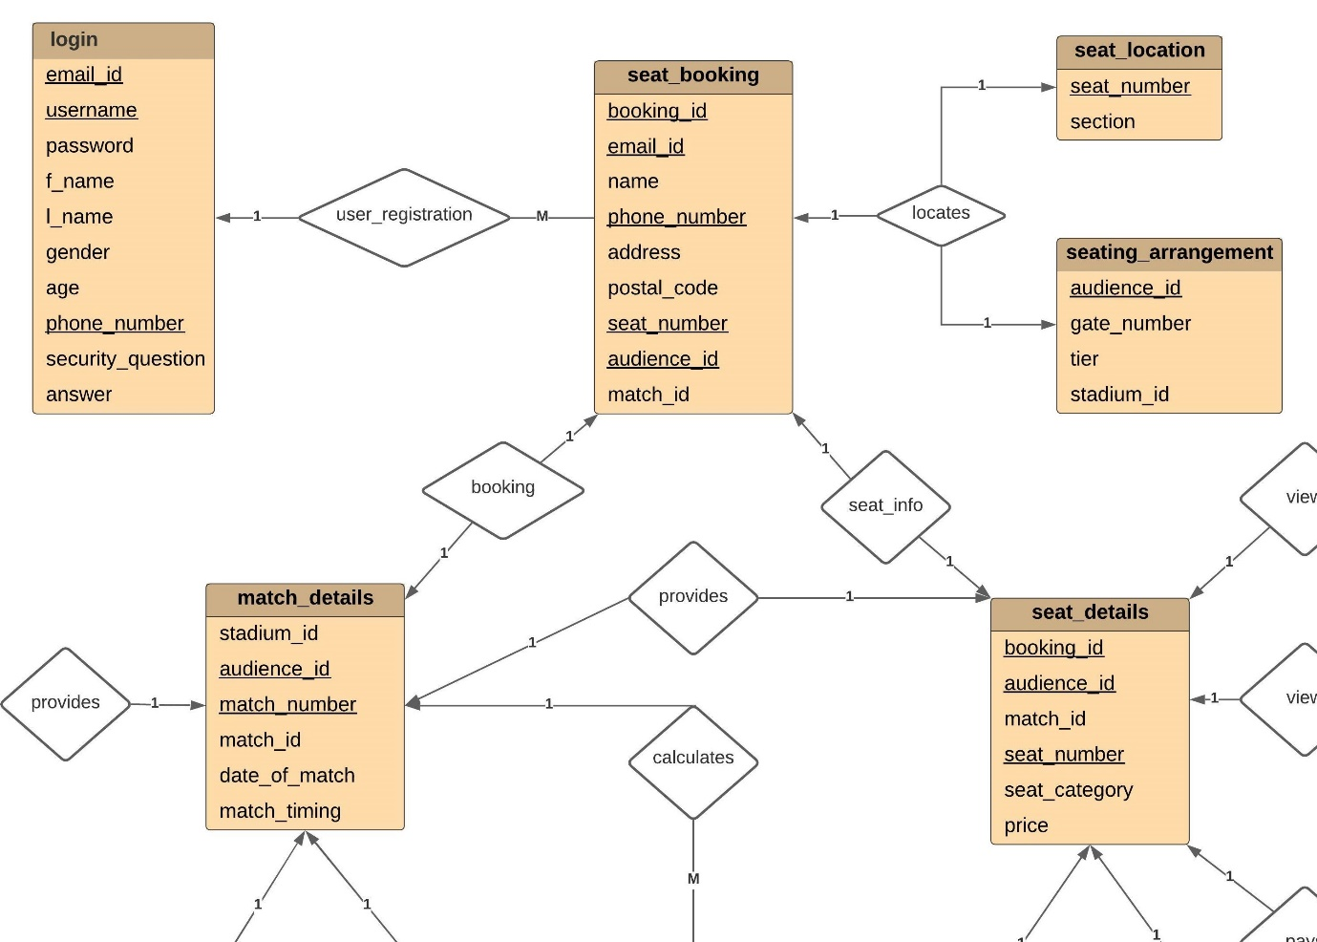

**Ujash Thakkar – 19BIT142**

**Assignment-2**

**Relational Model**

In This assignment every member creates 4 input table. And I create stadium_details, match_details, audience_verification and tickets_cancelled. In this relational model underlined attributes for primary key and every relational model has minimum at least one primary key. After creating 4 table I have to think about how all table are interrelated after the group discussion all doubt will be clear. After completing all the work by a group member that’s the time merge the final work.

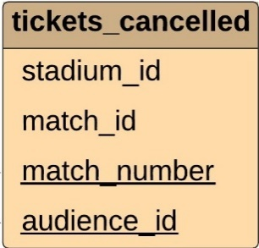 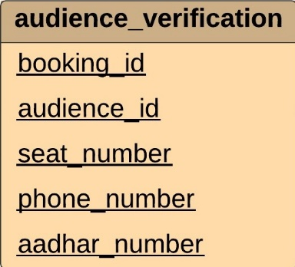 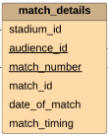 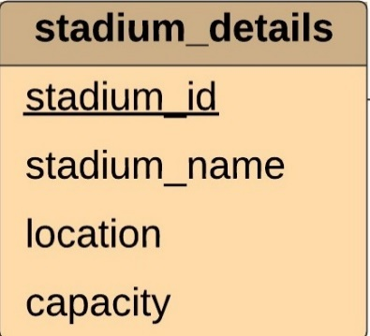

**Assignment-3**

**E-R model**

This Assignment was entity relationship model it’s quite easy because it based on assignment 2 which was Relational model after making of Relational model. After that I have to create relation sets between the assigned input tables and created the entity sets for the attributes. Between the stadium details and match details there will be relation of order which will be denoted by diamond that called by (provides) and entity will be denoted by rectangle. At the time when person was seat booking that time person see name of stadium and location of that and etc. The relationship between audience_verification and seat_details is verifies and the relationship between tickets_cancelled and seat_details is shows. Then we have given idea in Group and then we have made the diagram through online platform.

**Ananya Khandelwal – 19BIT144**

**Assignment – 2**

**Relational Model**

Our second Assignment was to make a relational model of our data base. This thing was new to us so we took some time to properly understand what a relational model is and how it is made we had a lot of group discussions about the relational model and when everyone was familiar with the model we began working in our respective provided field. We were supposed to make 4*N tables, so the four I worked upon were **tickets sold, advertisement, weather, tickets available.**  I was not clear about how to make the tables so I discussed with my group and we concluded that the table is to be made with these entities and attributes and the primary key is to be mentioned or highlighted so I made the tables accordingly. Then at last we had a discussion on foreign key to relate the tables with each other. After a lot of discussion and improvements the Assignment 2 came to an end and was made perfectly. Our understanding of the subject was quite better than before.

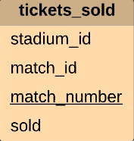 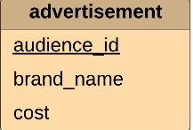 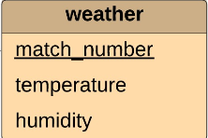 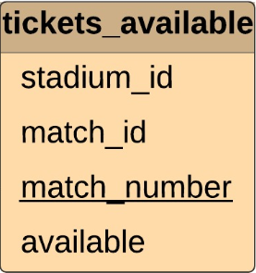

**Assignment – 3**

**E-R Model**

This assignment was just an upgrade of the previous one and it was completely a team work as we need to relate the tables with each other so we had arranged meetings accordingly and began the work of making the relations. Talking about my tables all the four were not related to each other therefore in our meetings we related each other’s table and came up with a proper ER Model and the model was created with the help of an online platform - [https://lucid.app/lucidchart/21c4d692-d021-4418-a7e8-7b0c9c5d97c6/edit?page=0_0#](https://lucid.app/lucidchart/21c4d692-d021-4418-a7e8-7b0c9c5d97c6/edit?page=0_0%23)

